HTML Attributes

📘 What are HTML Attributes?
# Source: AI Source: Provided by: [Data Path: Persons Table -> ID Column: 1, Name_En Column: Motasem Essam] -> From: [ChatGPT] on [5/6/2026]
HTML attributes are extra pieces of information added to HTML tags to modify or describe how an element behaves or appears.

🧱 Basic Syntax
# Source: AI Source: Provided by: [Data Path: Persons Table -> ID Column: 1, Name_En Column: Motasem Essam] -> From: [ChatGPT] on [5/6/2026]
Attributes are written inside the opening tag:
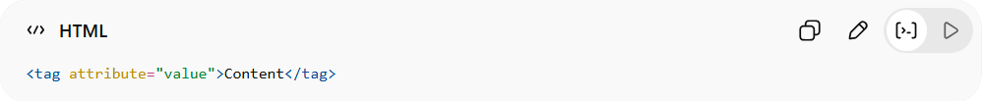
<tag attribute="value">Content</tag>

🧾 Example
# Source: AI Source: Provided by: [Data Path: Persons Table -> ID Column: 1, Name_En Column: Motasem Essam] -> From: [ChatGPT] on [5/6/2026]
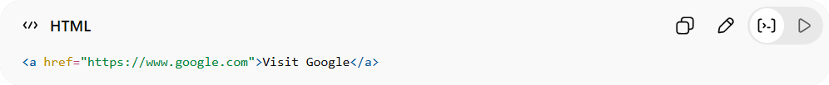
<a href="https://www.google.com">Visit Google</a>
- <a> → anchor (link) tag
- href → attribute
- "https://www.google.com" → value
👉 The href attribute tells the browser where the link goes.

🧠 More Examples
# Source: AI Source: Provided by: [Data Path: Persons Table -> ID Column: 1, Name_En Column: Motasem Essam] -> From: [ChatGPT] on [5/6/2026]
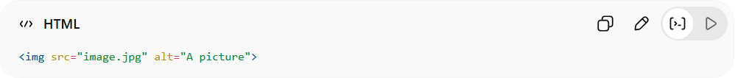
<img src="image.jpg" alt="A picture">
- src → image source (file path)
- alt → alternative text (for accessibility)

⚙️ Key Points
# Source: AI Source: Provided by: [Data Path: Persons Table -> ID Column: 1, Name_En Column: Motasem Essam] -> From: [ChatGPT] on [5/6/2026]
- Attributes are always in the opening tag
- Usually come in name="value" pairs
- They provide extra details or control behavior

🚀 In short:
# Source: AI Source: Provided by: [Data Path: Persons Table -> ID Column: 1, Name_En Column: Motasem Essam] -> From: [ChatGPT] on [5/6/2026]
HTML Attributes = extra information inside a tag that controls how it works or looks.

